Exercise 3: Stored Procedures

**Scenario 1:** The bank needs to process monthly interest for all savings accounts.

* + **Question:** Write a stored procedure **ProcessMonthlyInterest** that calculates and updates the balance of all savings accounts by applying an interest rate of 1% to the current balance.

**Code:**

-- Scenario 1: Process monthly interest for all savings accounts

CREATE OR REPLACE PROCEDURE ProcessMonthlyInterest IS

BEGIN

UPDATE accounts

SET balance = balance + (balance * 0.01)

WHERE account_type = 'Savings';

COMMIT;

END;

/

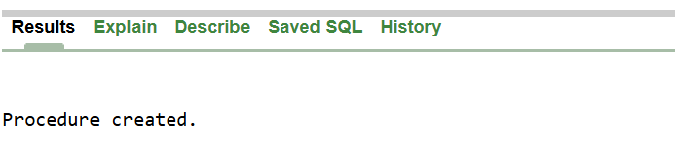

**Scenario 2:** The bank wants to implement a bonus scheme for employees based on their performance.

* + **Question:** Write a stored procedure **UpdateEmployeeBonus** that updates the salary of employees in a given department by adding a bonus percentage passed as a parameter.

**Code:**

-- Scenario 2: Update employee salary with bonus in a department

CREATE OR REPLACE PROCEDURE UpdateEmployeeBonus(

dept_id IN NUMBER,

bonus_pct IN NUMBER -- e.g., pass 10 for 10%

) IS

BEGIN

UPDATE employees

SET salary = salary + (salary * bonus_pct / 100)

WHERE department_id = dept_id;

COMMIT;

END;

/



**Scenario 3:** Customers should be able to transfer funds between their accounts.

* + **Question:** Write a stored procedure **TransferFunds** that transfers a specified amount from one account to another, checking that the source account has sufficient balance before making the transfer.

**Code:**

-- Scenario 3: Transfer funds between accounts

CREATE OR REPLACE PROCEDURE TransferFunds(

from_acc_id IN NUMBER,

to_acc_id IN NUMBER,

amount IN NUMBER

) IS

insufficient_funds EXCEPTION;

v_balance NUMBER;

BEGIN

-- Check balance of source account

SELECT balance INTO v_balance

FROM accounts

WHERE account_id = from_acc_id

FOR UPDATE;

IF v_balance < amount THEN

RAISE insufficient_funds;

END IF;

-- Deduct from source

UPDATE accounts

SET balance = balance - amount

WHERE account_id = from_acc_id;

-- Add to destination

UPDATE accounts

SET balance = balance + amount

WHERE account_id = to_acc_id;

COMMIT;

EXCEPTION

WHEN insufficient_funds THEN

DBMS_OUTPUT.PUT_LINE('Transfer failed: Insufficient funds.');

ROLLBACK;

WHEN OTHERS THEN

DBMS_OUTPUT.PUT_LINE('Transfer failed: ' || SQLERRM);

ROLLBACK;

END;

/

